Café Shree Take Away Counter
Café Shree Take Away Counter is a micro enterprise works from last six months. Different snacks like theralai, elayappam, kozhukotta, ennapathirietc are available here. And also they provide idli, dosa, sambar and so on as breakfast for schools.
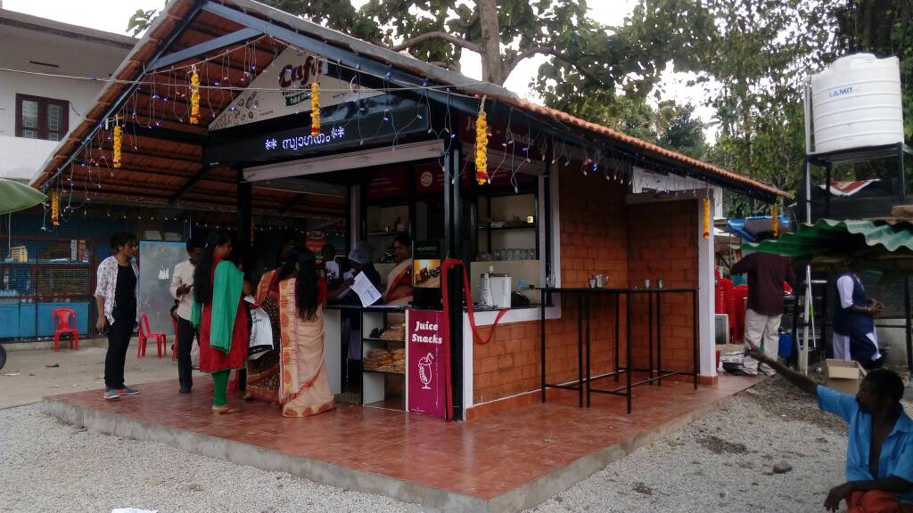
It is the only café which works with steamer and RO plant. It has started with 4.5 lakhs as SC Fund and 1.5lakhs as loan. At same time 125 kozhukotta can steam in the steamer. RO plant enables them to use the utensils sterile and tidy.
Café Shree Take Away Counter earns 7000 to 8000 rupees in a day. In the sabarimala season they earn up to 10000 rupees in a day. Cafe has created a brand image for bakery as well as hotel. Besides it brought a handsome income for them.

